## horizontal line



Haze Removal Using Dark Channel Prior

Digital Image Processing Project (CS-663)

25.10.2019

Anugole Sai Gaurav 170070008

Titas Chakroborty 170070019

Jayesh Choudhary 170070038

# Objective

Our objective is to de-haze a single hazy image using a dark channel prior. The formation equation of a hazy image is given as :

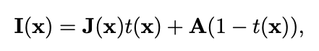

Where I represents the observed intensity, J represents the scene radiance, t represents the transmission and A represents the atmospheric light.

Dark channel prior helps decouple this equation into additive terms.

We are using single hazy images found from the internet as test images.

# Assumptions and Important Parameters

1. Atmospheric light is as minimum as possible because the dark channel value, in that case, is not close to zero.
2. We assume that transmission in a patch is constant.
3. Patch size in finding the transmission map is crucial as larger patch size gives better natural results but as we increase the patch size the assumption that the transmission in a patch is constant is no longer valid
4. This method is invalid when the scene object is inherently similar to the air light.
5. While recovering the scene radiance, if the sky is very far, transmission is very close to zero and so it posses a problem. Therefore we take another parameter t0. We specify it to be 0.05 and take the minimum of both values.
6. Dehazing the image entirely will give an un-natural feel so we keep a small amount of haze by using another tunable parameter omega with value 0.95 (Only 95 % haze is removed).

# 

## Using histogram equalization haze is not removed. (Though it is clearly more visually pleasing)

## The third image is that without soft-matting and the fourth image is one with soft-matting.

## Scene Radiance is not as bright as atmospheric light so the image after haze-removal looks a little dim.

## Dehazing achieved with soft-matting is better than that without soft-matting because we are refining and smoothening the transmission map

## The transmission maps are compared below

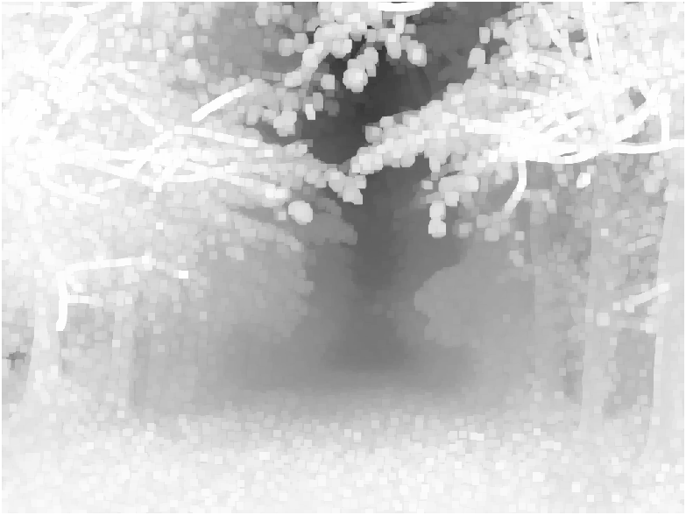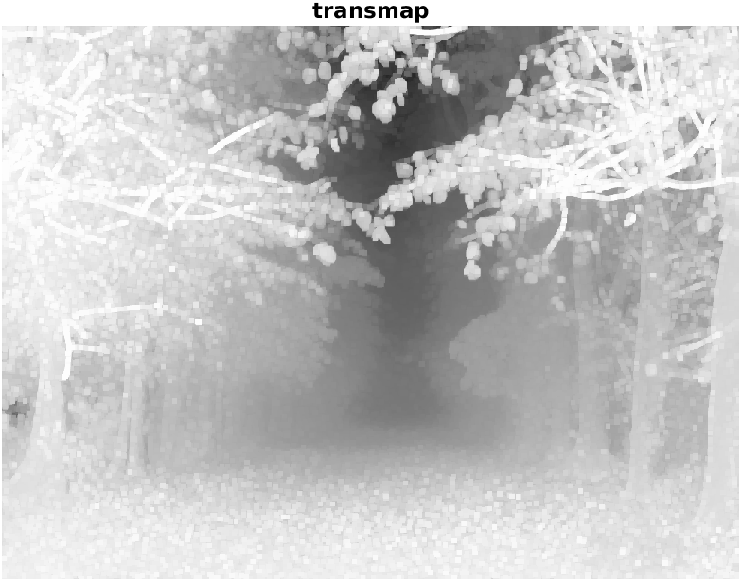

## The transmission map is more refined in the 2nd image due to laplacian smoothening.

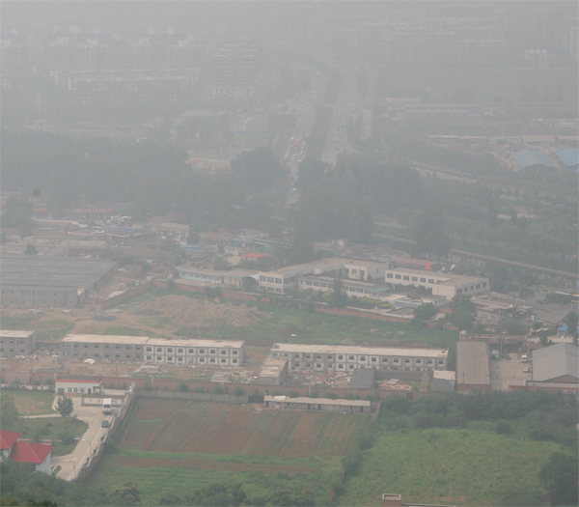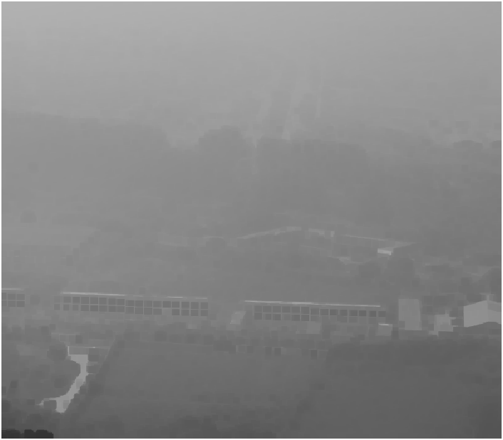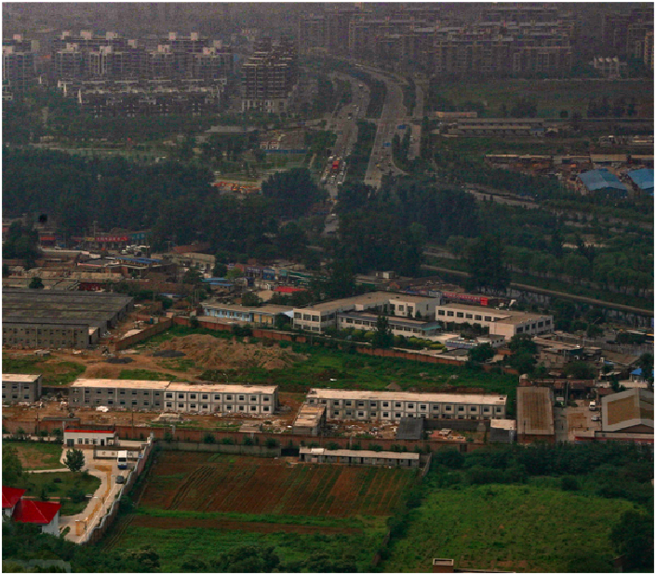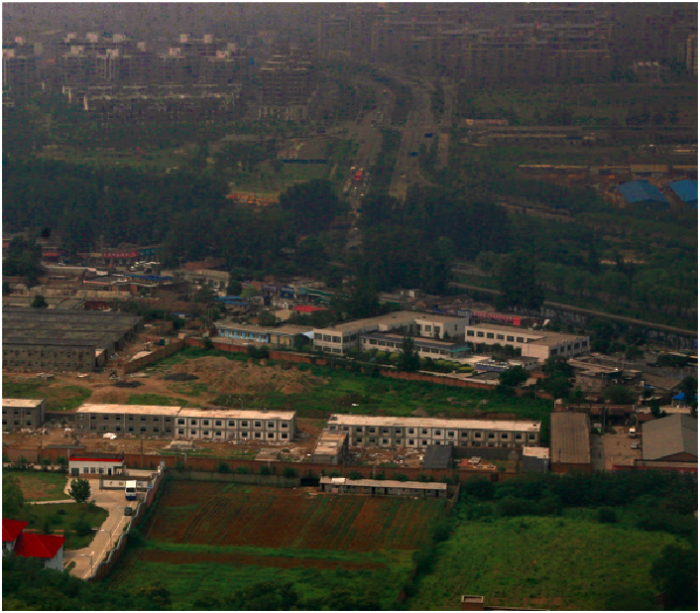

## The 2nd image is that of atmospheric light and 3rd and 4th images are de-hazed images.

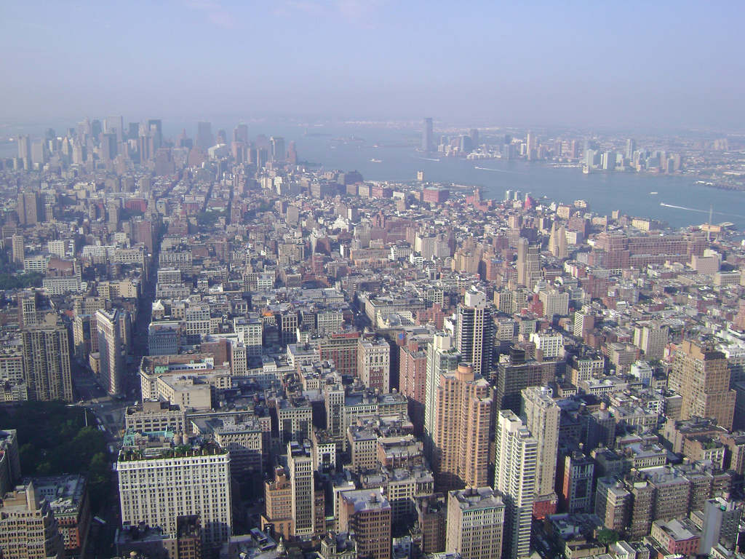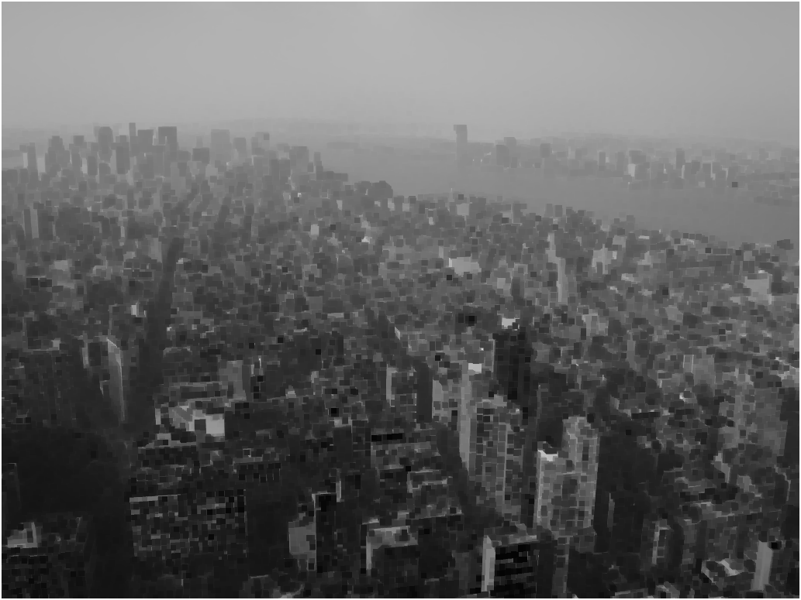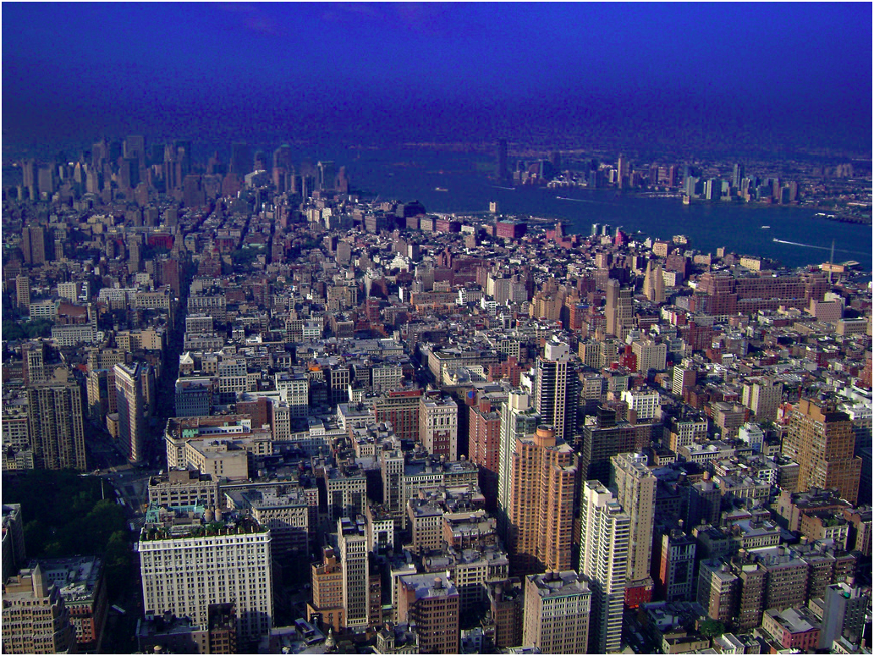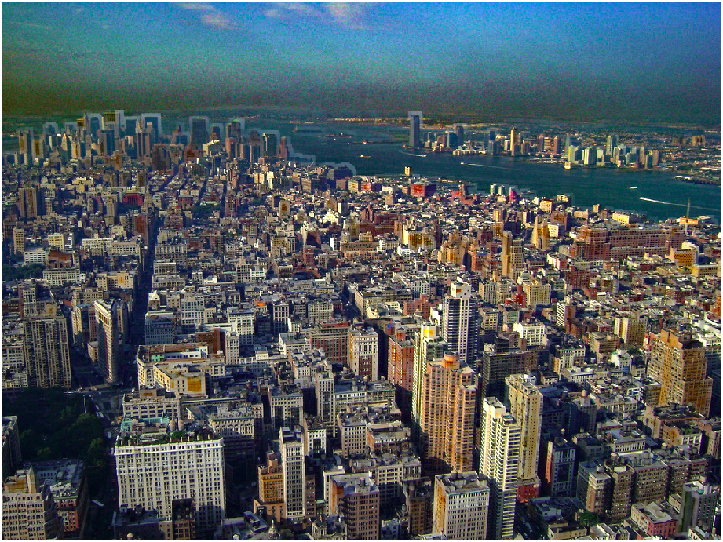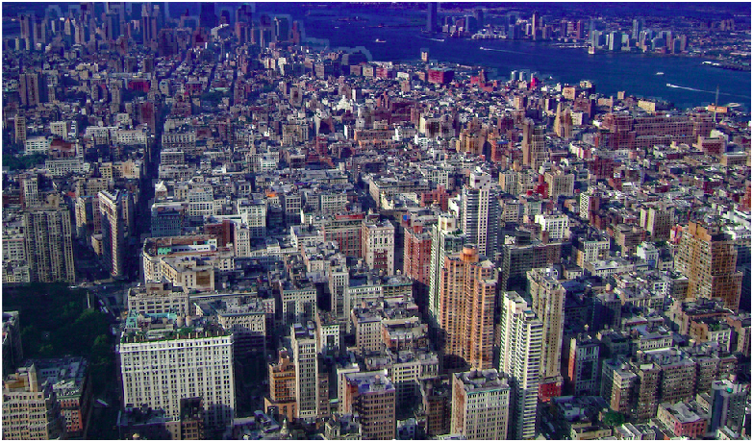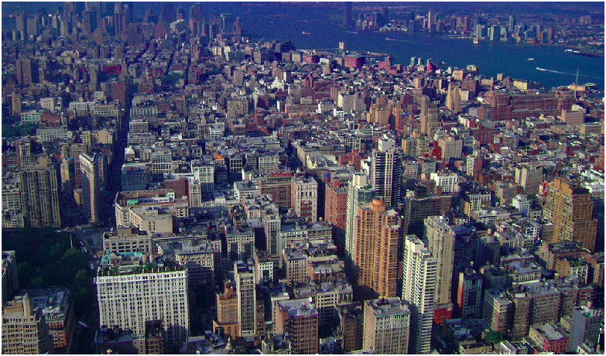

## When a lot of atmospheric light is there, it affects the de-hazing process. When we manually crop the image the output image is much better.

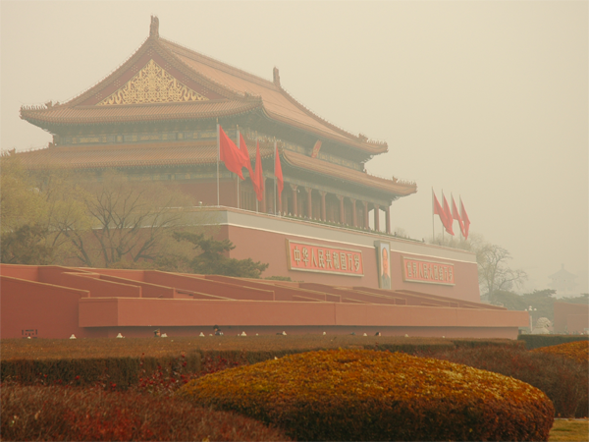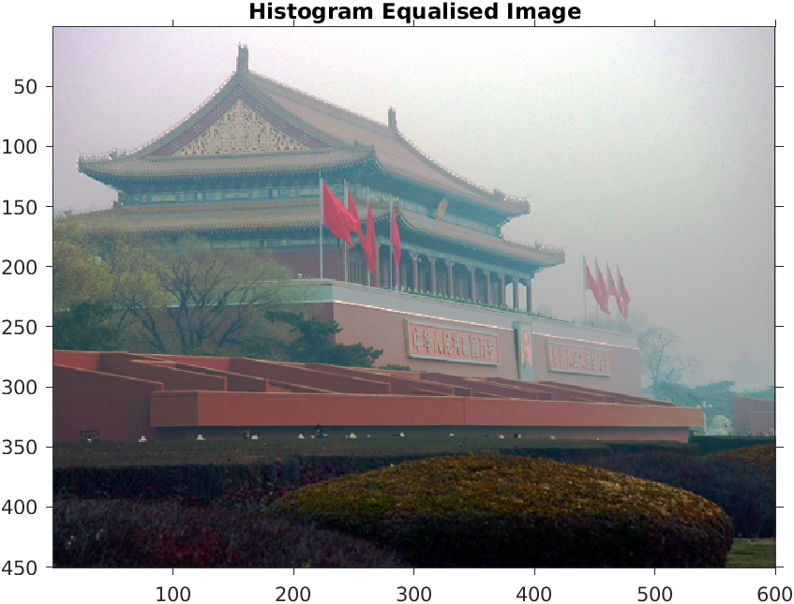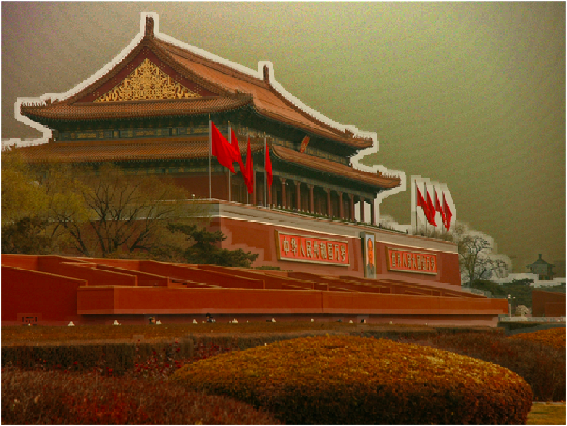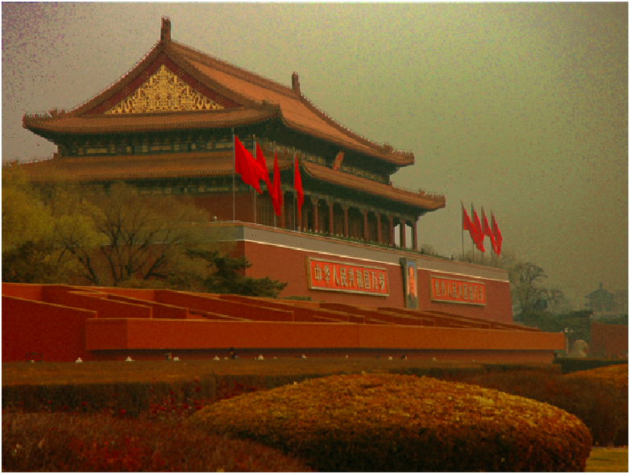

## Histogram Equalization results in loss of the yellowish tinch of the image.

## Without soft-matting, we can see the white boundary which is removed after using soft-matting as the transmission map now is more close to the actual boundary.

## 

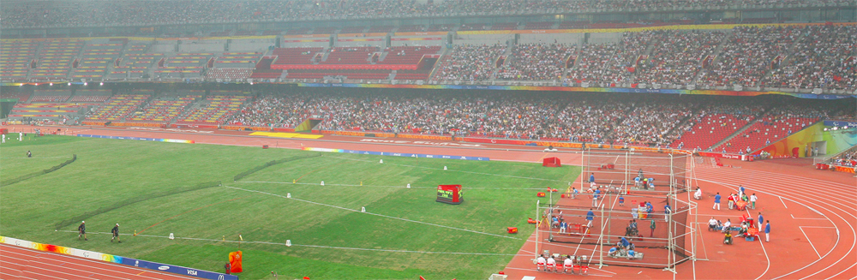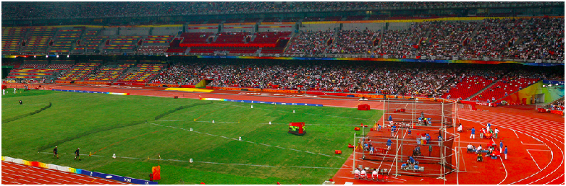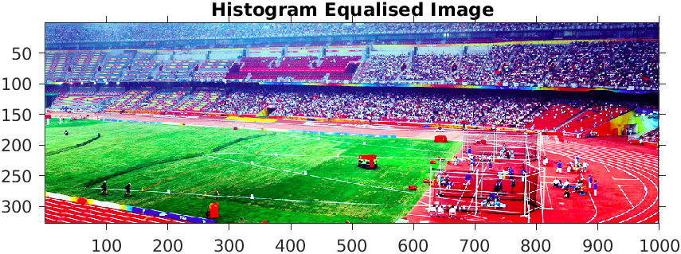

## Histogram Equalization results in the un-natural image whereas our result (second image) gives a much better image with just the haze removed.

## This Algorithm doesn’t give pleasing results when there are more high intensity pixels!! (Original, Transmission map, De-Hazed Image)

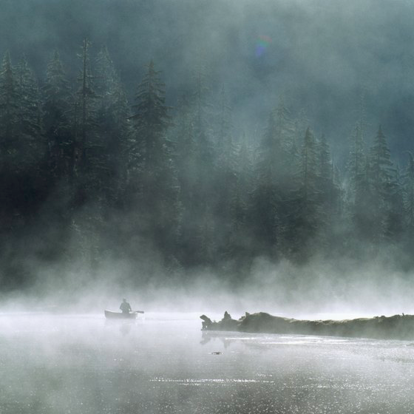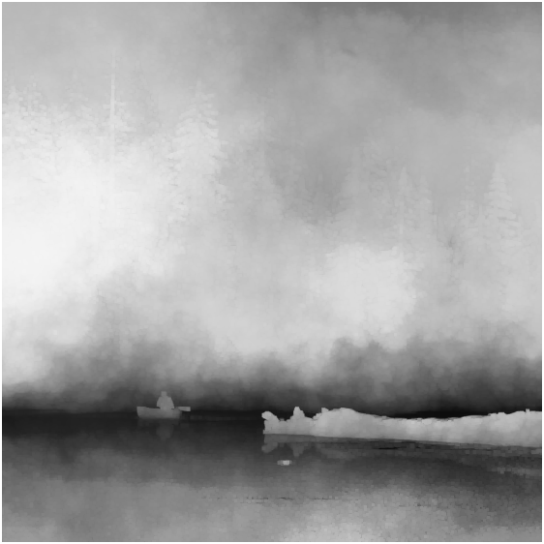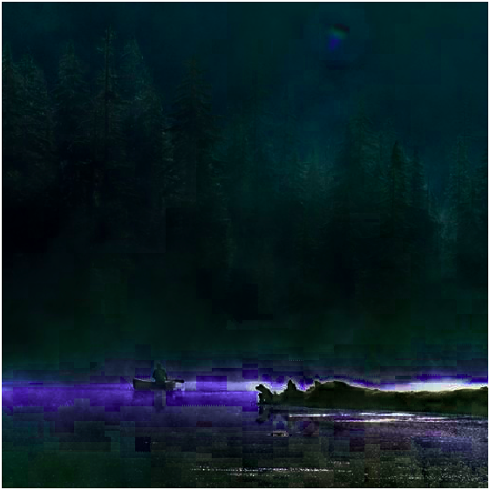

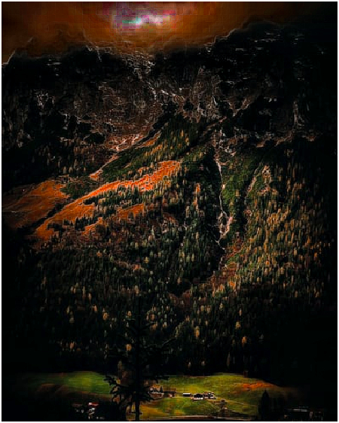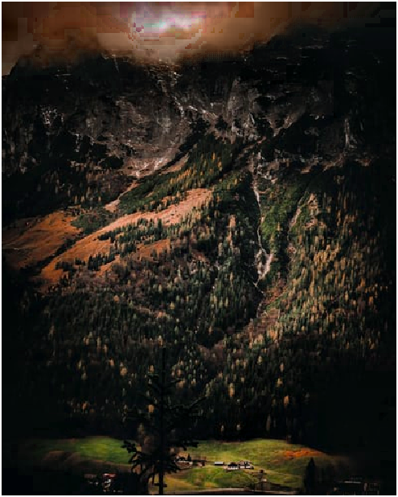

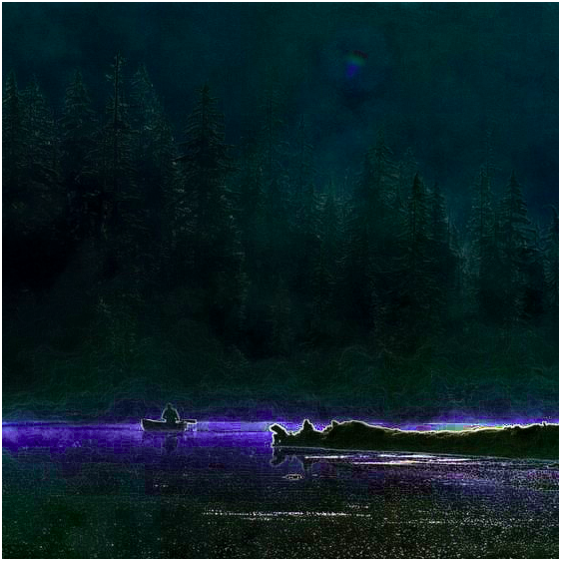

## For images with smaller dimensions, we need to decrease the patch size for better results